# Creating an SQS Queue

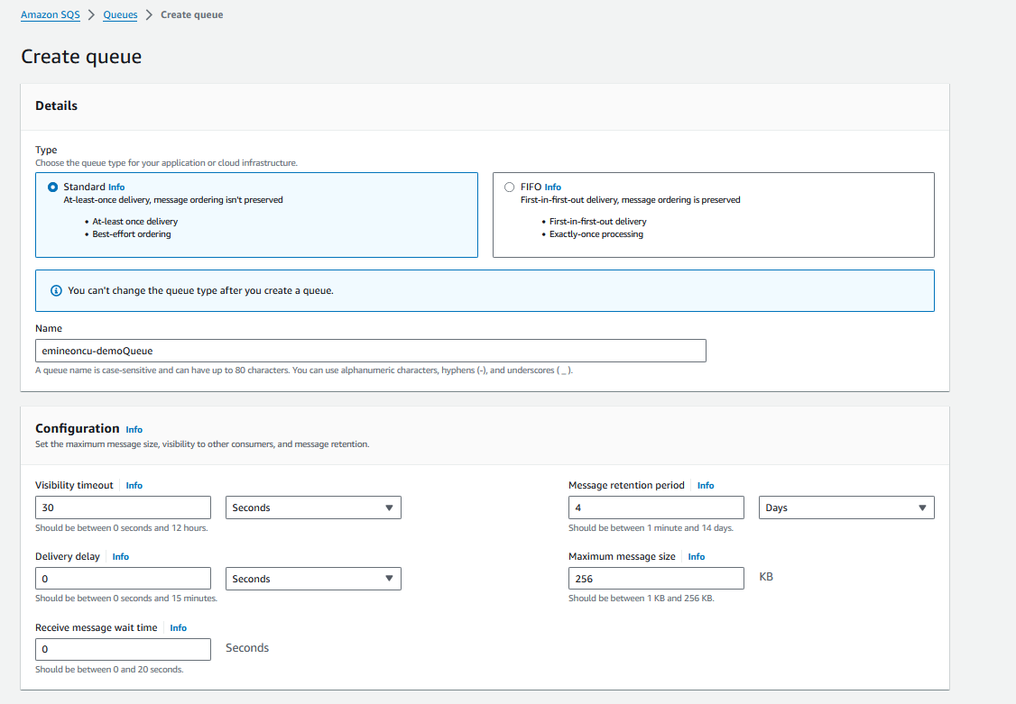

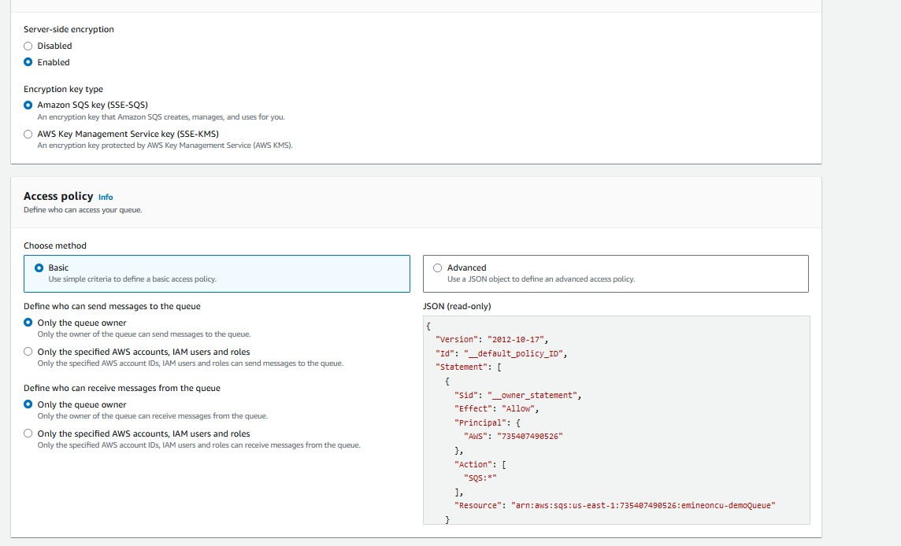

* **Created demo SQS Queue.**

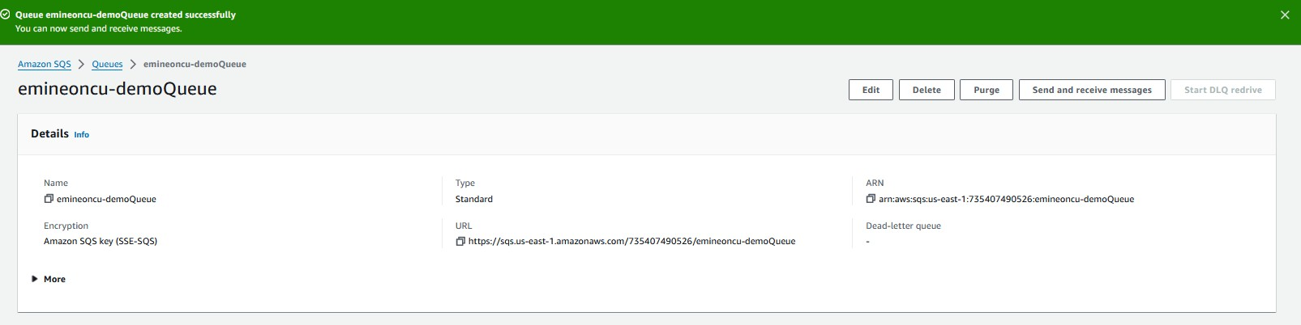

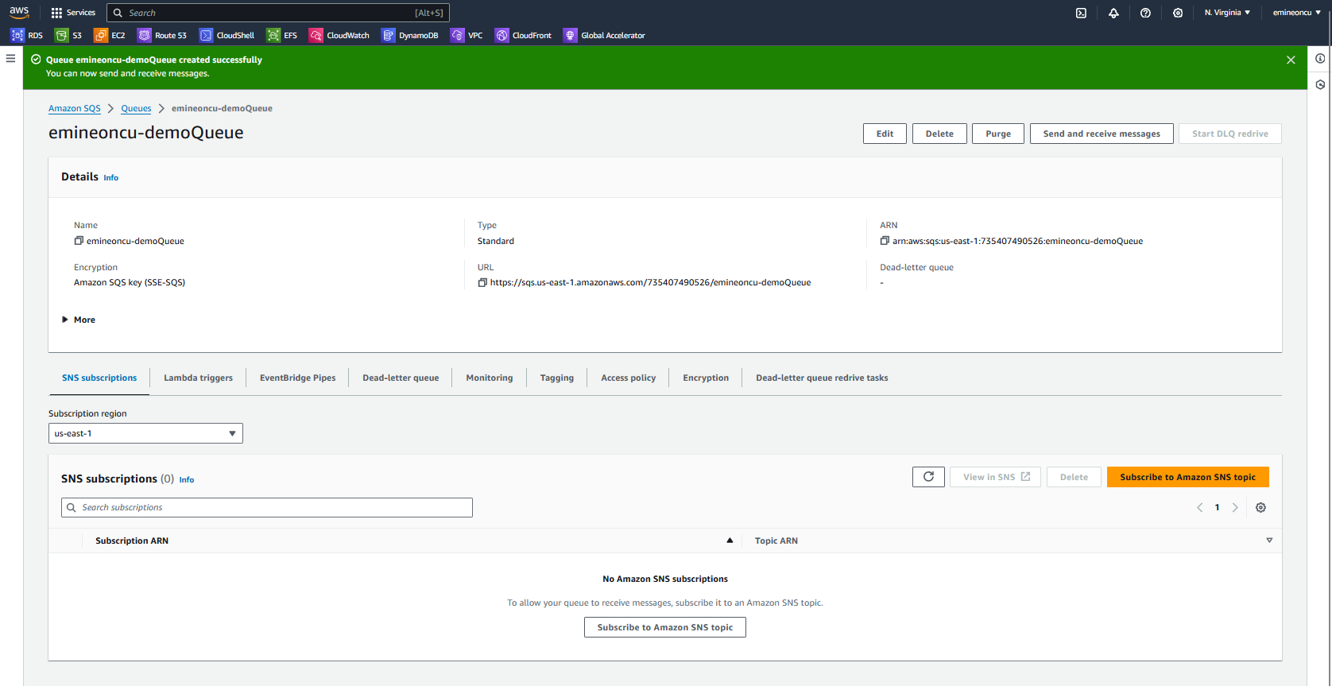

* **Sending first message to the queue**

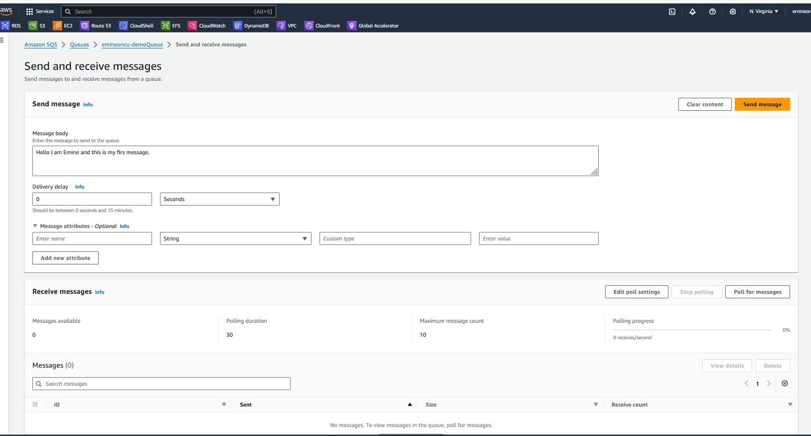

* **Message details**

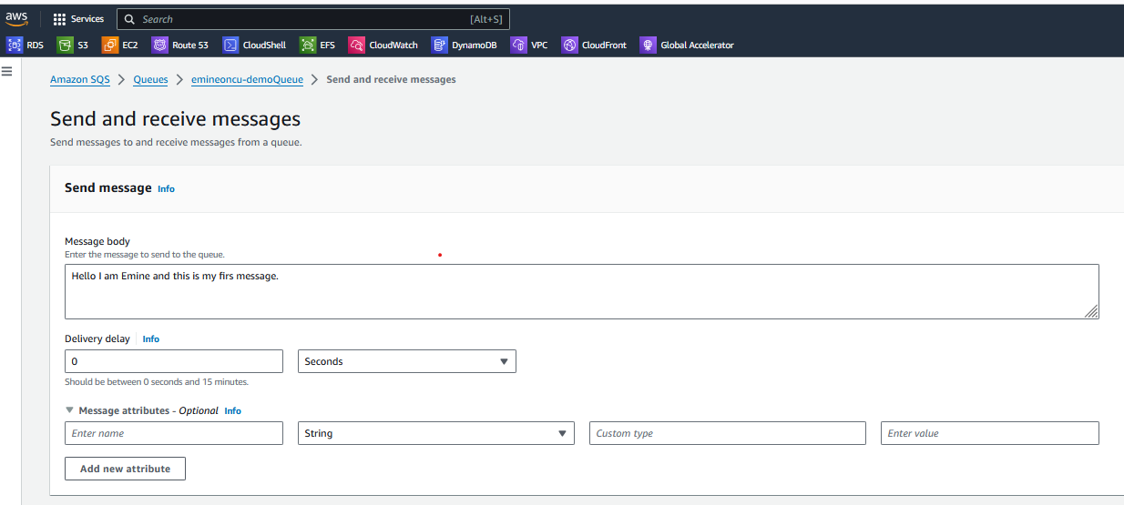

* **Message sent.**

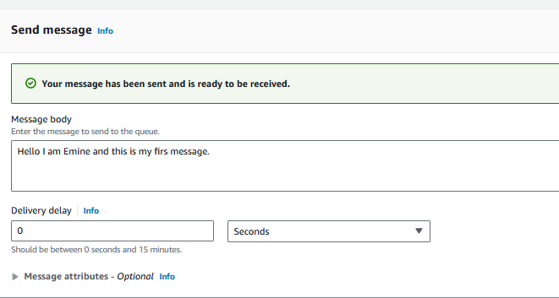

* **After sending the message, when I poll for it, I can receive it.**

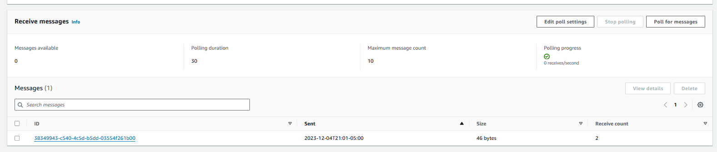

* **Message received.**

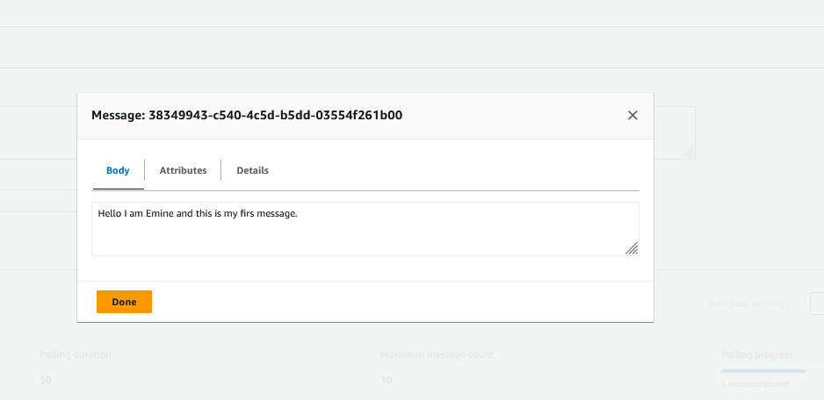

* **Purging the queue will empty the queue, and deleting will actually remove the queue.**
* **Monitoring section of SQS Queue.**

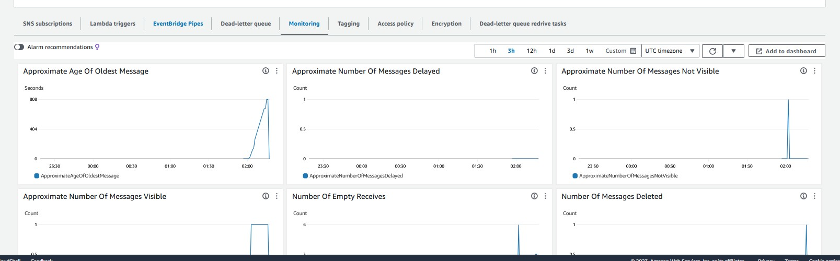

* **Creating an SNS topic.**

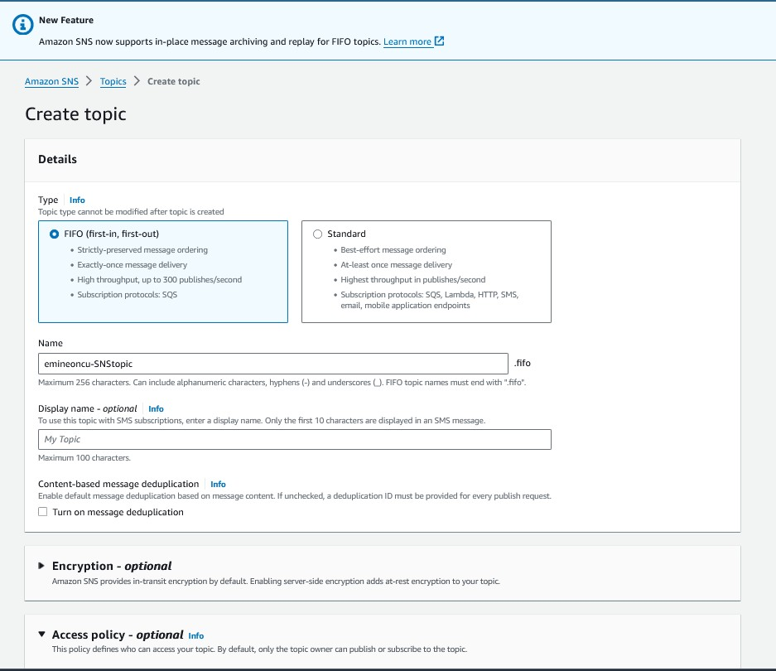

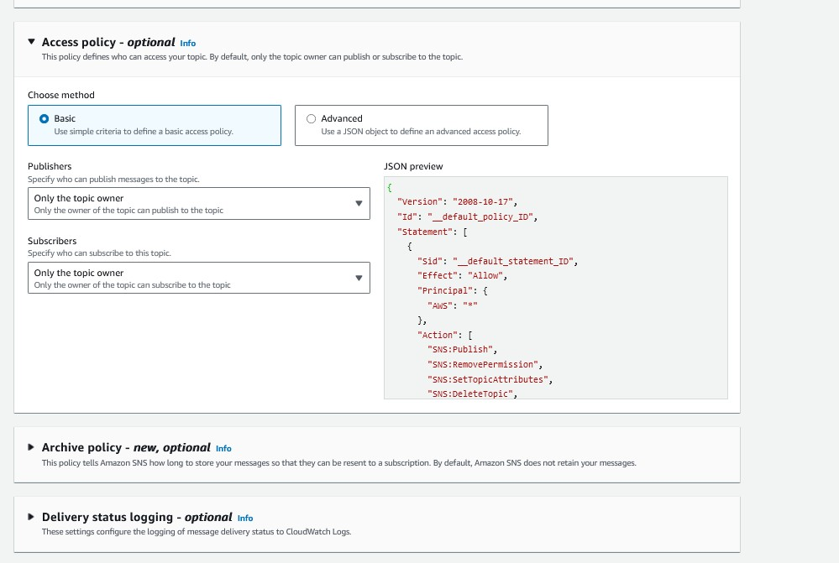

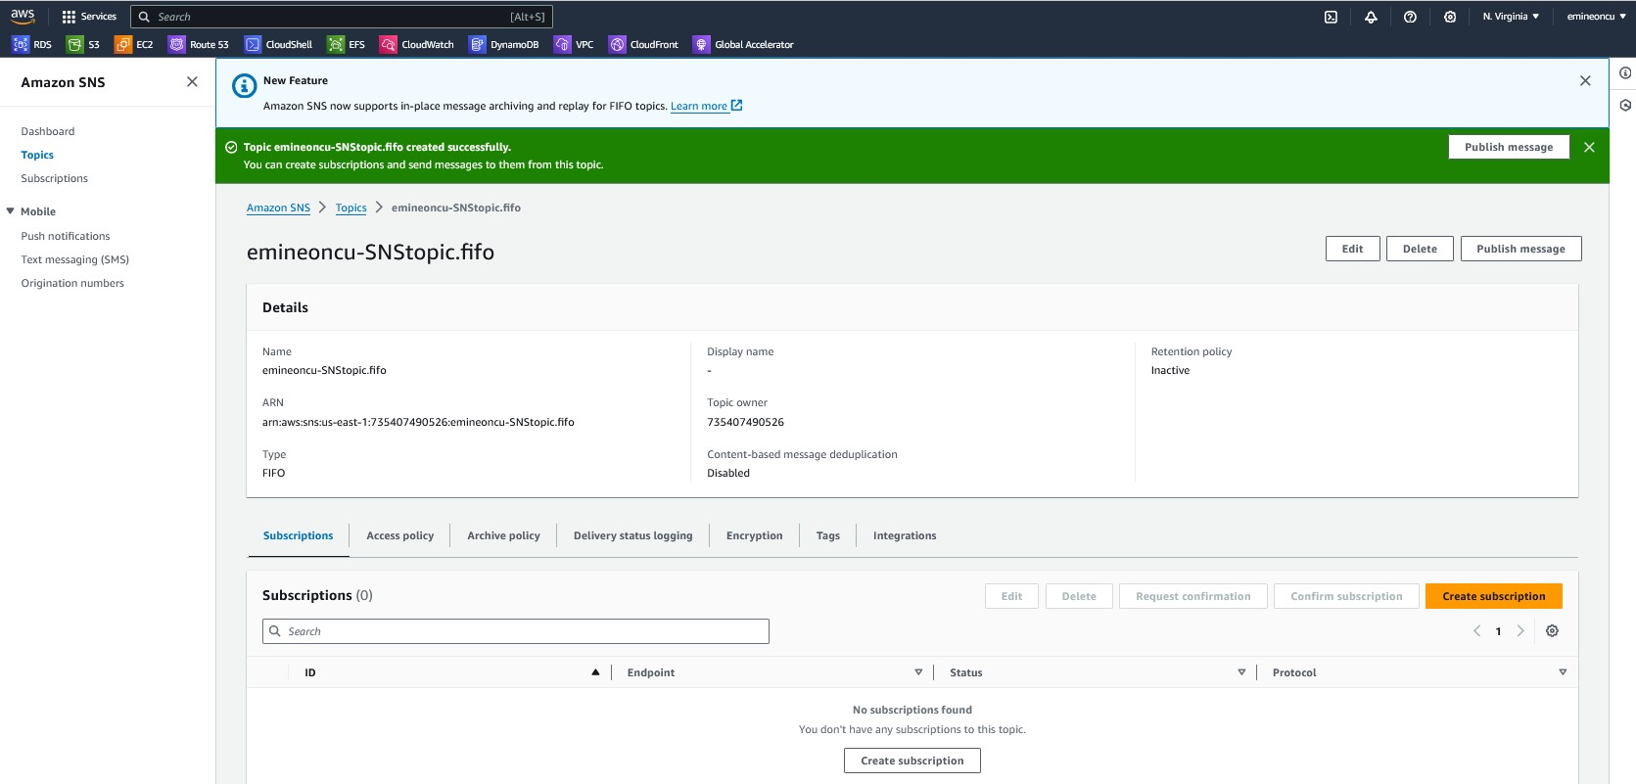

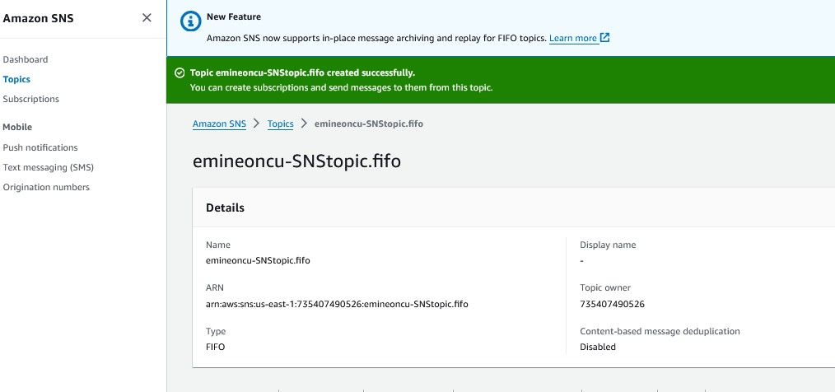

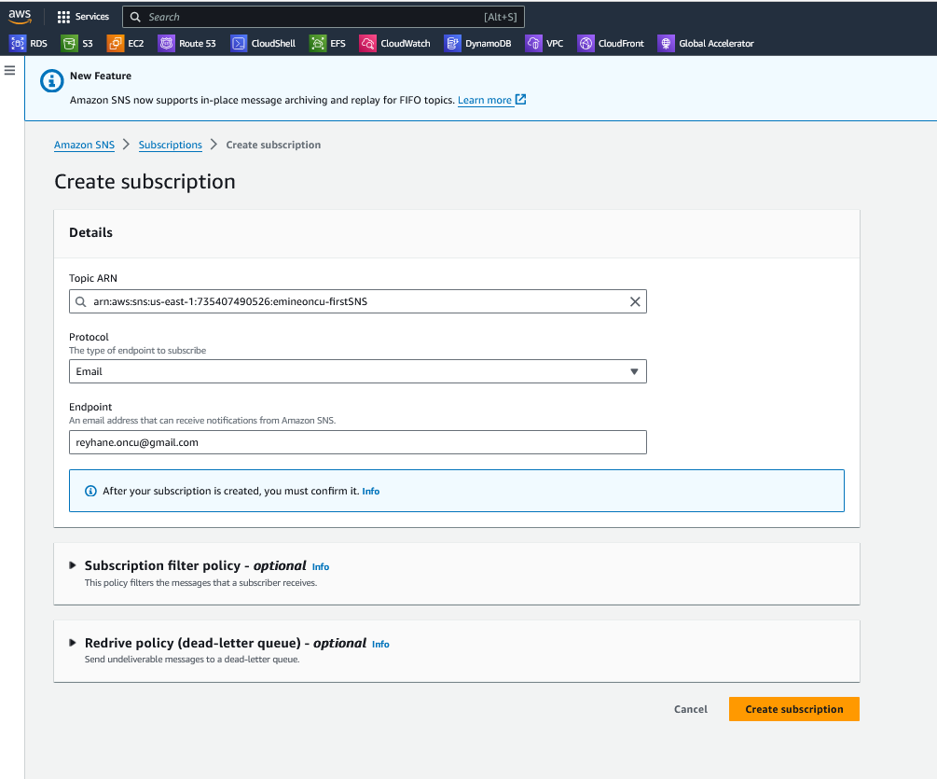

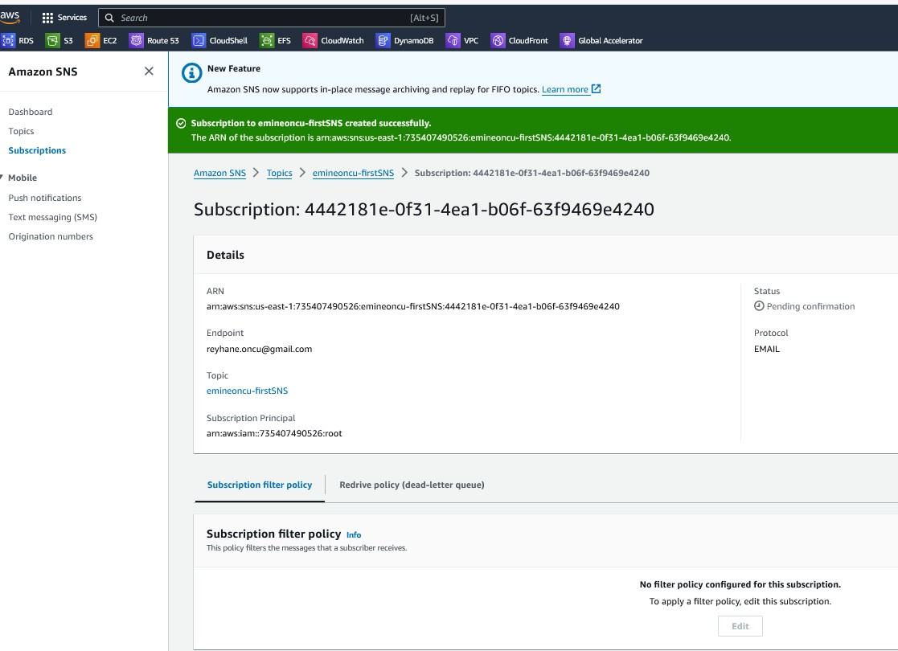

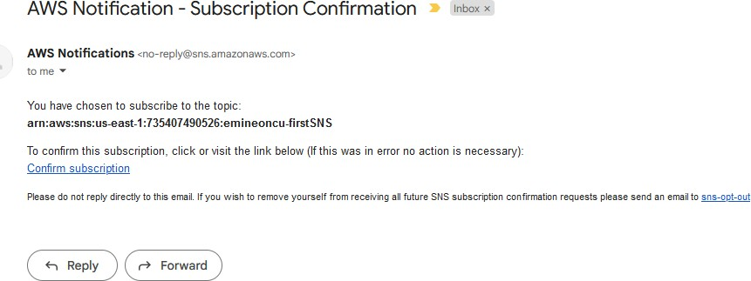

* **Creating a subscription to the SNS topic using personal email**

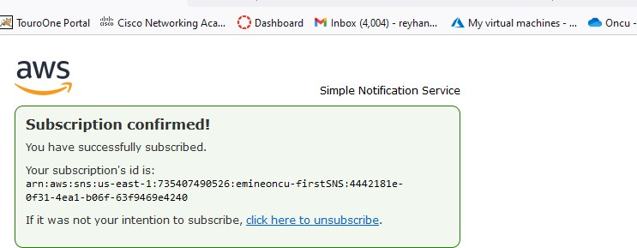

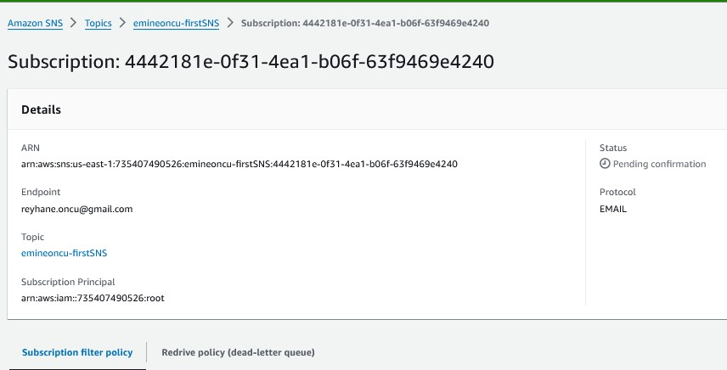

* **Publishing a message to the SNS topic**

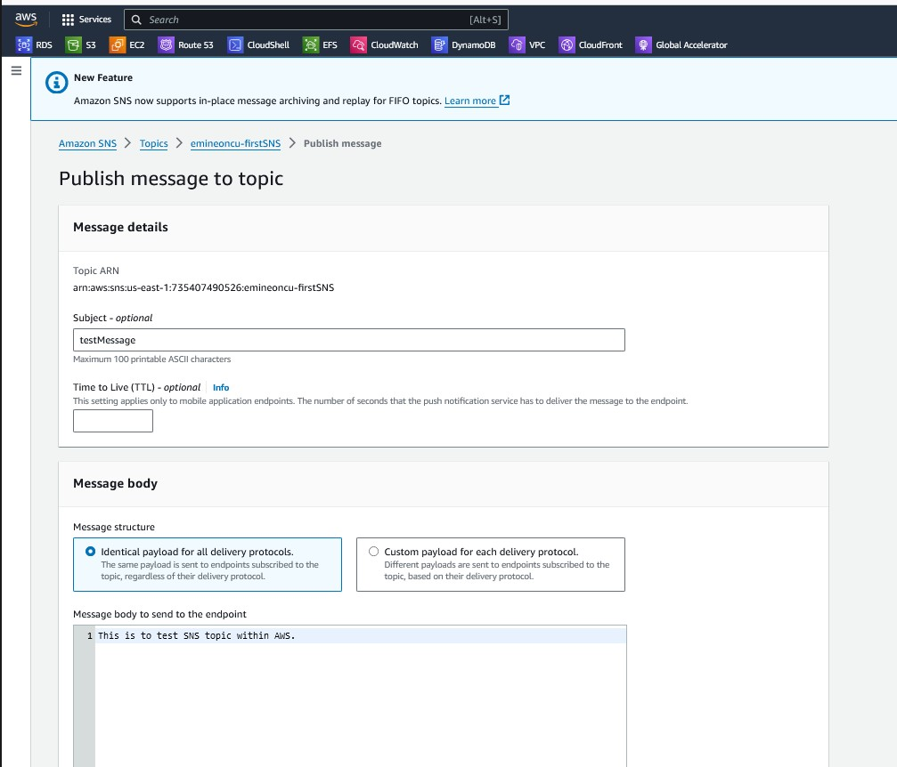

* **Since we subscribed to this SNS topic via email, the message that was published in it was received in the email.**

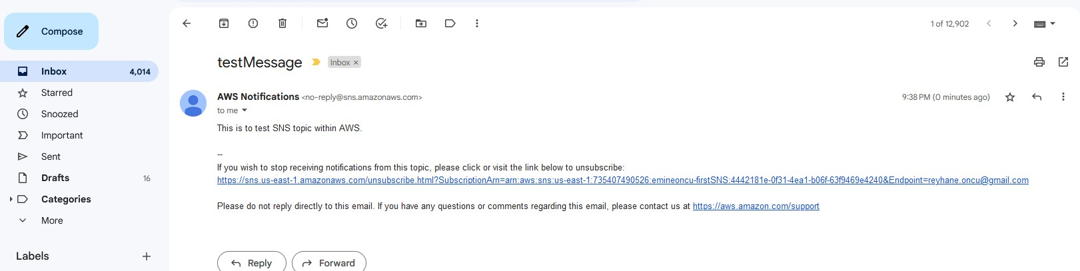

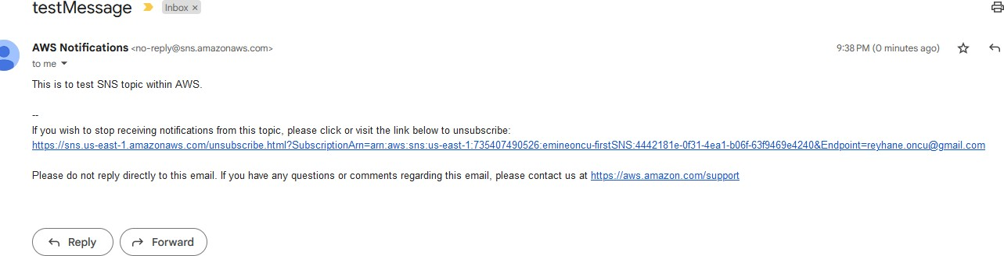

* **Using Fanout pattern**

Publishing message to SNS topic

* **Created emineoncu-demoQueue**

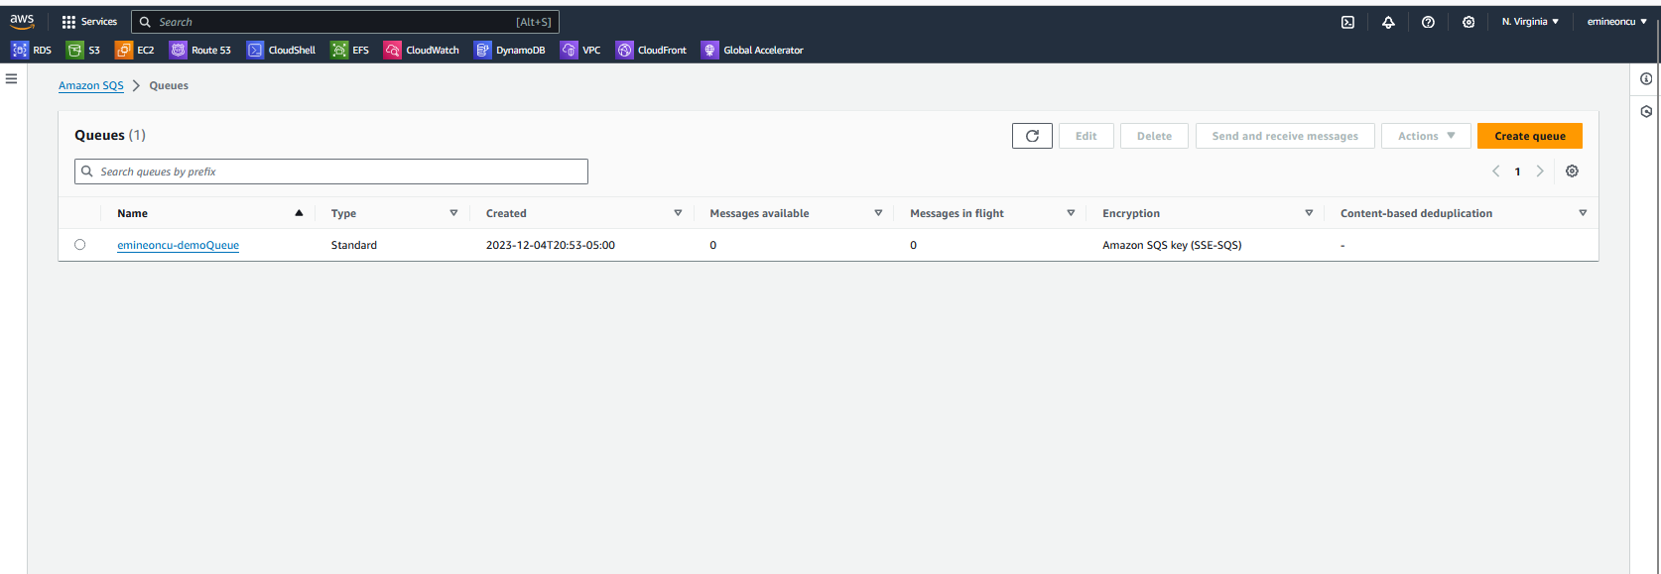

* **Two SQS queues available to receive SNS topic.**

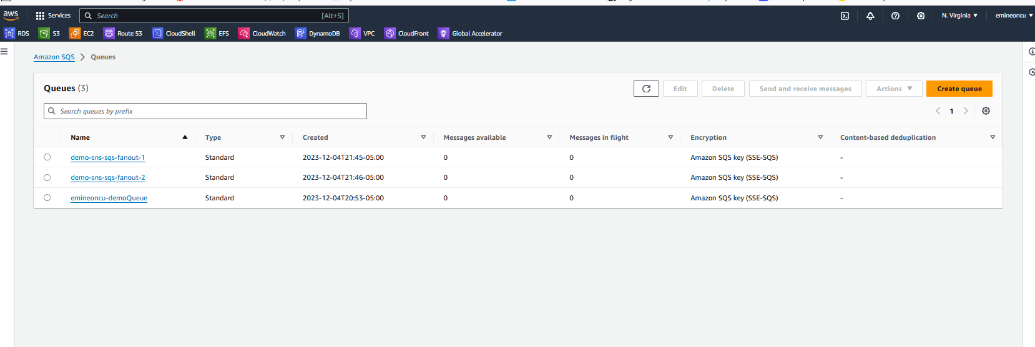

* **Publishing message to SNS topic.**

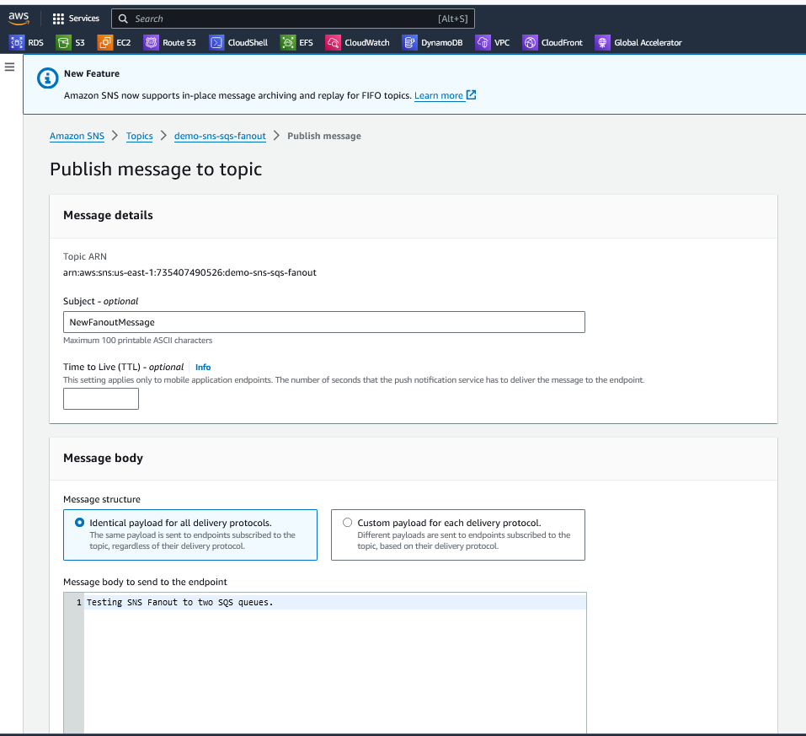

* **Creating subscription to SNS topic to be subscribed by SQS fanout1.**

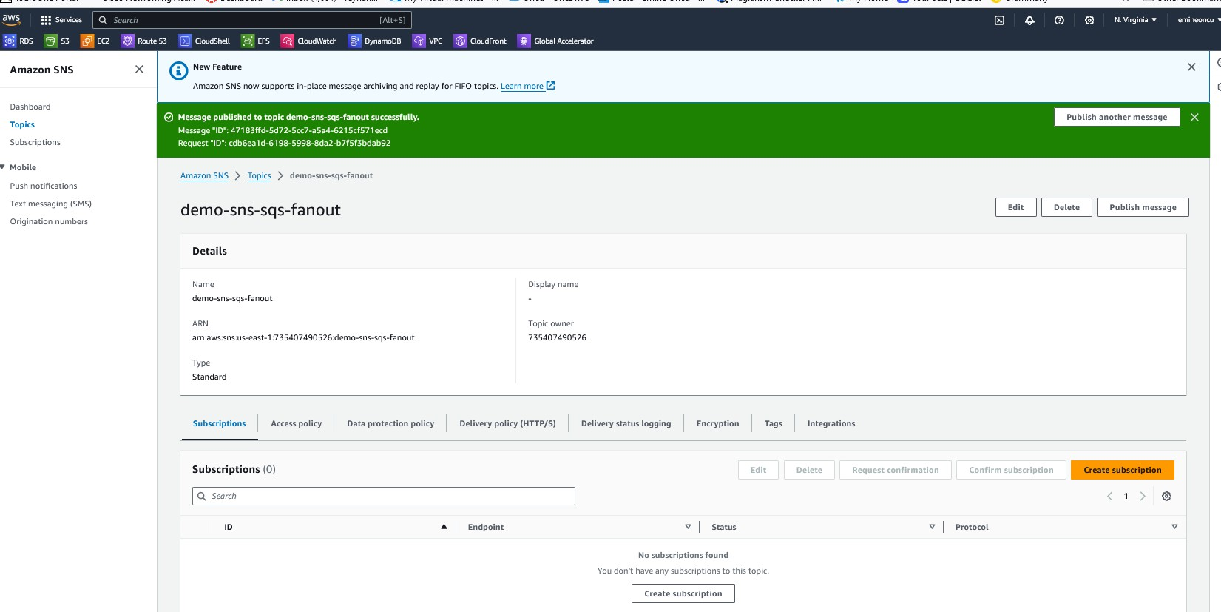

* **Subscription fanout 1**

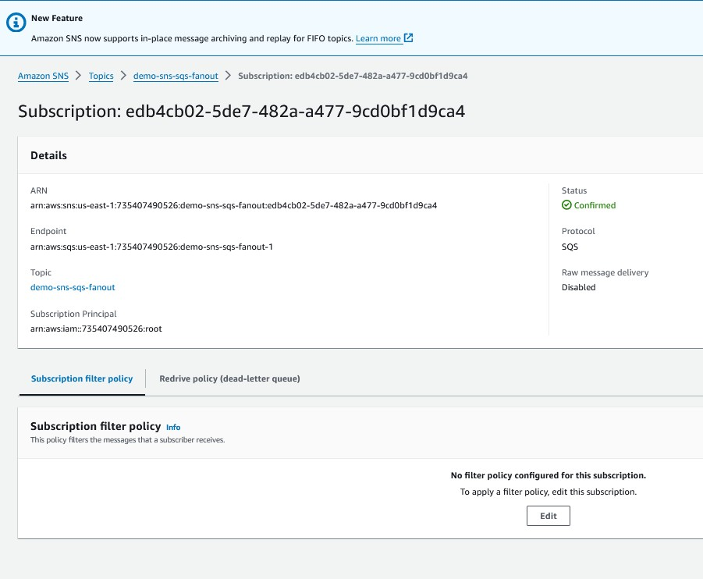

* **Adding subscription to SQS fanout2**

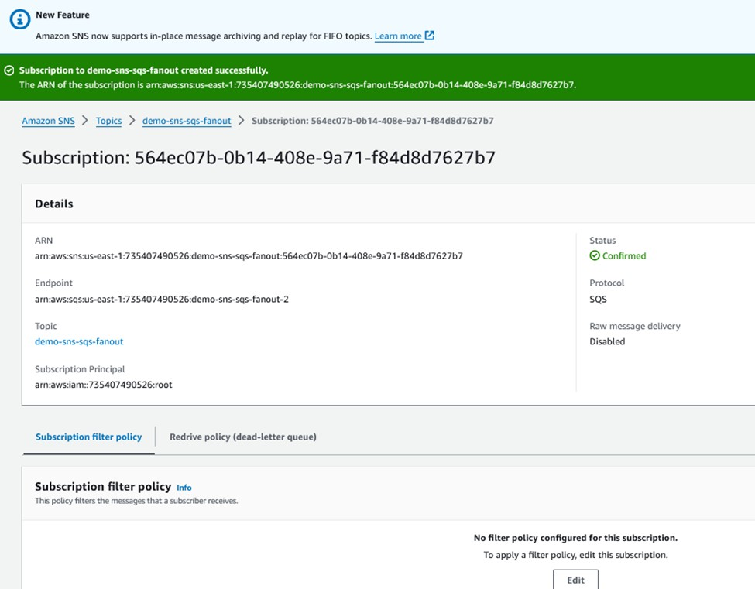

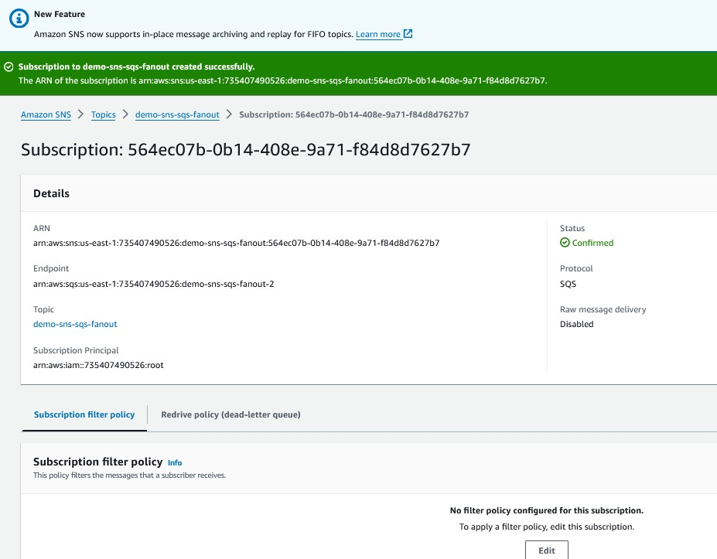

Confirm Subscription

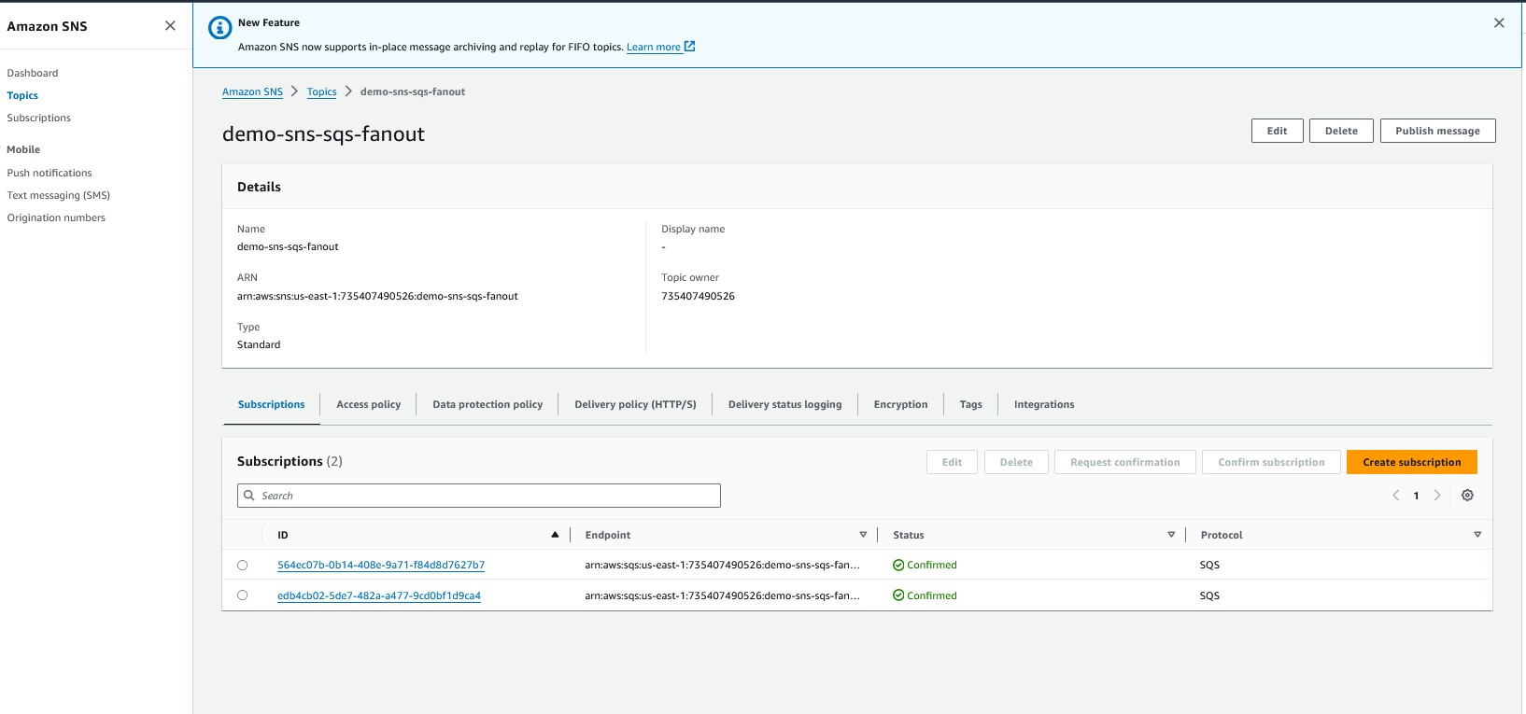

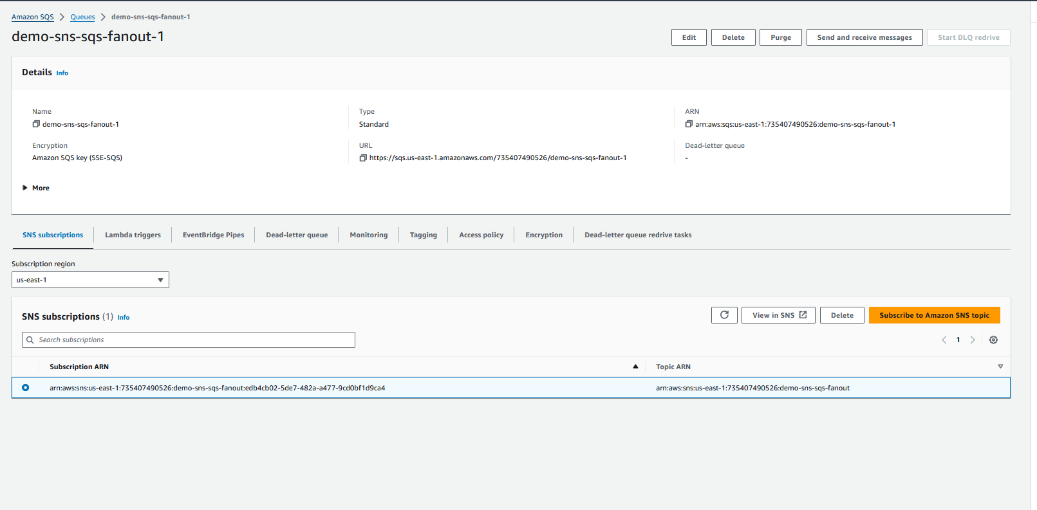

* **Publishing a message in SNS topic**

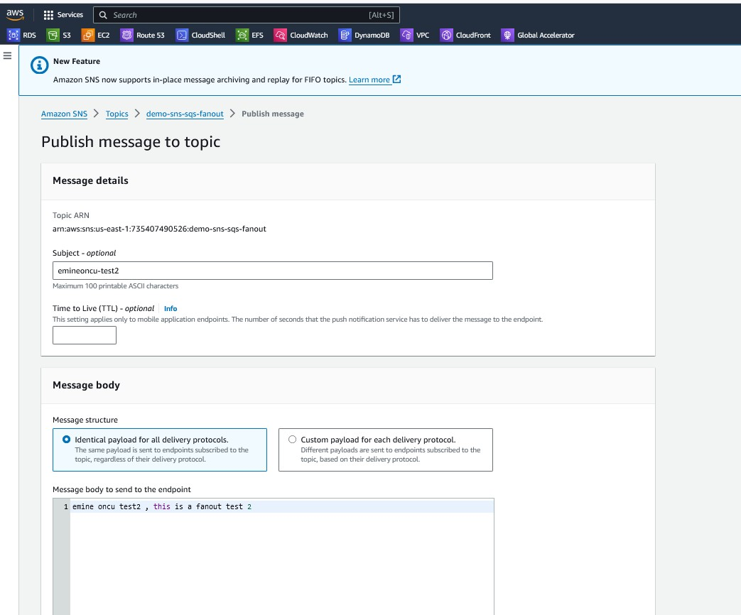

* **SQS Queue Showing SNS topic being subscribed.**
* **Created SQS-SNS fanout pattern.**

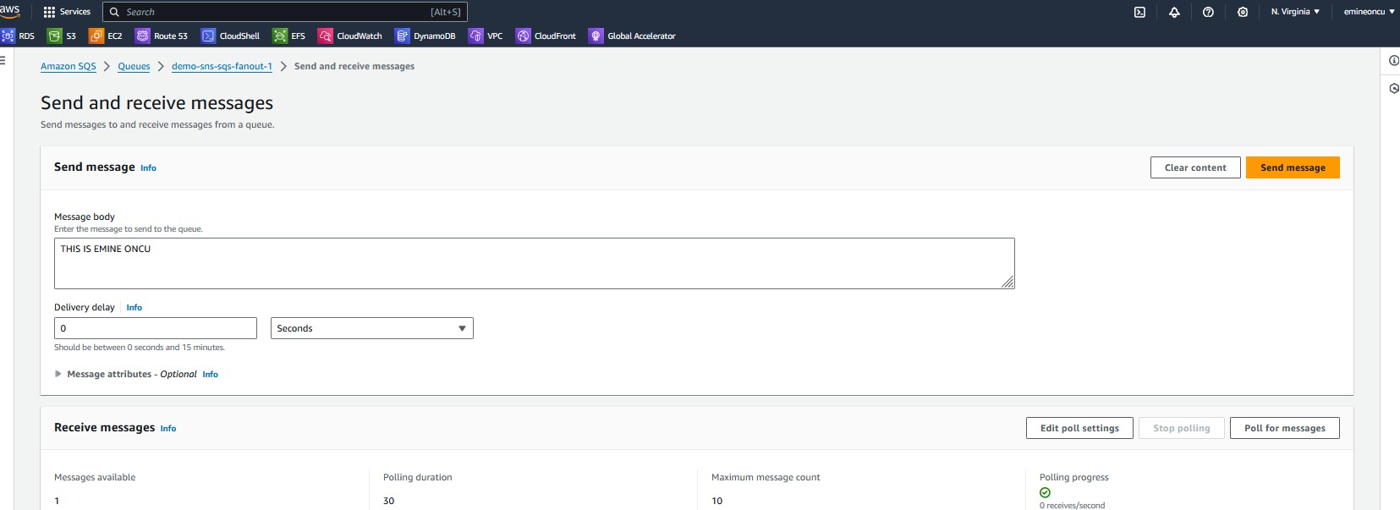

# FANOUT 1

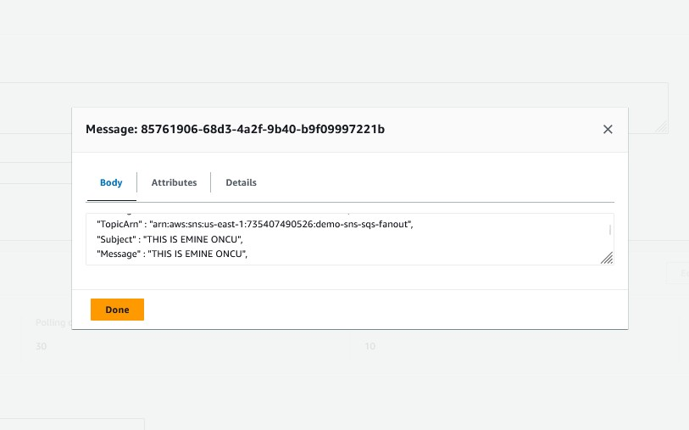

* **FAN OUT 2**

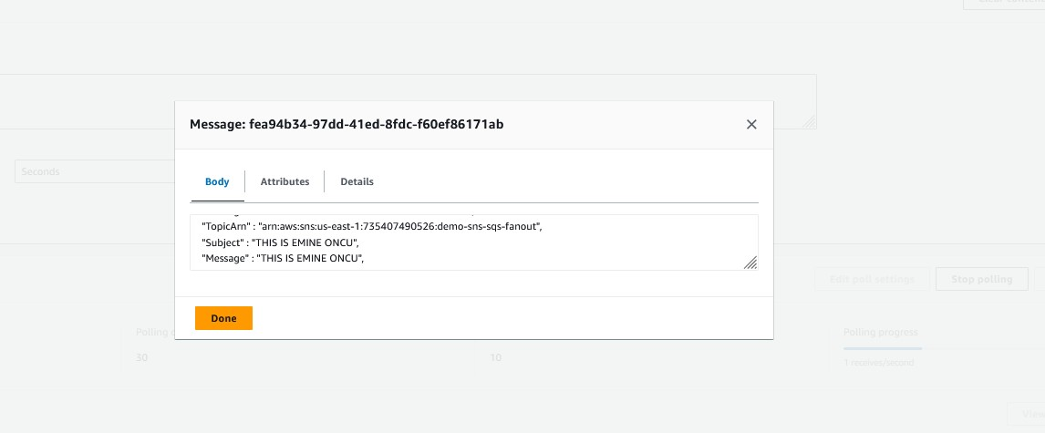

Kinesis Data Streams

* 1. What is it?

“Scalable and durable real-time data streaming service that can continuously capture gigabytes of data per second from hundreds of thousands of sources.” [Link to AWS](https://aws.amazon.com/pm/kinesis/?gclid=Cj0KCQiAsburBhCIARIsAExmsu7HNsJzS0LPm2aol_YAtXLYlUZ-oydsUZDsFMa3lV7sHPHAM8sAJ_oaAsckEALw_wcB&trk=4ff6a80d-0ba8-4bbe-90d7-9e00902fb427&sc_channel=ps&ef_id=Cj0KCQiAsburBhCIARIsAExmsu7HNsJzS0LPm2aol_YAtXLYlUZ-oydsUZDsFMa3lV7sHPHAM8sAJ_oaAsckEALw_wcB%3AG%3As&s_kwcid=AL!4422!3!651737511551!e!!g!!amazon%20kinesis%20data%20streams!19845796012!146736268789)

* 1. Real World Use Case

“Zillow”, “Netflix”

* 1. Architecture diagram

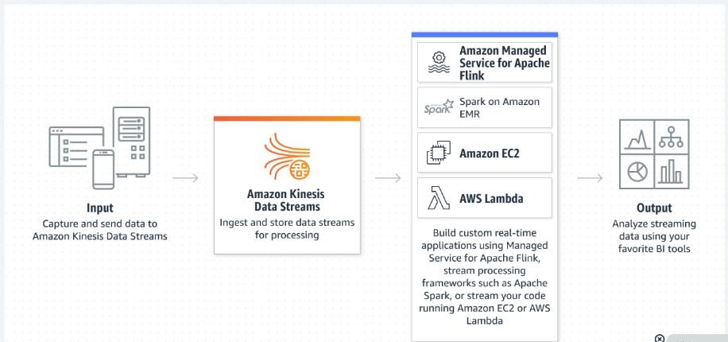

Kinesis Data Firehose

1. What is it?

“Capture, transform, and load data streams into AWS data stores for near real-time analytics

with existing business intelligence tools.” [Link to AWS](https://aws.amazon.com/pm/kinesis/?gclid=Cj0KCQiAsburBhCIARIsAExmsu7HNsJzS0LPm2aol_YAtXLYlUZ-oydsUZDsFMa3lV7sHPHAM8sAJ_oaAsckEALw_wcB&trk=4ff6a80d-0ba8-4bbe-90d7-9e00902fb427&sc_channel=ps&ef_id=Cj0KCQiAsburBhCIARIsAExmsu7HNsJzS0LPm2aol_YAtXLYlUZ-oydsUZDsFMa3lV7sHPHAM8sAJ_oaAsckEALw_wcB%3AG%3As&s_kwcid=AL!4422!3!651737511551!e!!g!!amazon%20kinesis%20data%20streams!19845796012!146736268789)

1. Real World Use Case

“REDFIN”, HEARST”

1. Architecture diagram

